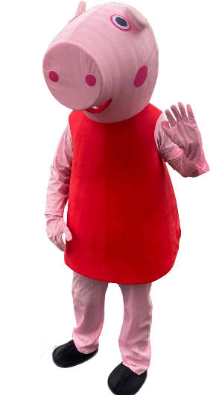
Set includes:
- 1 x Head
- 1 x Body suit
- 1 x Trousers
- 1 x Pair of shoes
- 1 x Gloves

Caution!
While wearing the suit, you may feel quite warm. For hygiene reasons, please make sure to wear appropriate clothing underneath. Aim to cover as much skin as possible.

Guide
- Put on the trousers.
- Put on the shoes.
- Wear the body suit. Take your time with this step, especially around the shoulders and sleeves, to avoid any pulling.
- Put on the headpiece. Secure using the chin strap. Peppa’s mouth is in line with your eyes so you will need to look down for your guests to see Peppa’s full head. Especially for photographs.
- Put on your gloves. They are long so make sure you took them in underneath the body sleeves. There is Velcro to attach the gloves and the sleeves.
Get ready to bring Peppa to life!

IMPORTANT!
Be careful releasing your shoulders out of the body suit. Edge your arms out of the sleeves gradually and it is best to release one shoulder at a time. Please do not pull from the cuff of the sleeve as this increases the risk of ripping.

Deposit
A deposit has been established. Once the suit is returned and inspected, the full deposit will be refunded via bank transfer, provided there are no damages. If any damages are discovered, the deposit may be partially refunded or not refunded at all, depending on the extent of the damage.
Terms and conditions are on page 2 of this document.
Any Questions?
If you need any assistance at all while hiring the suit, then please call Stuart on 07593 711600.

Mascot Outfit Hire Terms and Conditions
- Hire Agreement
  - The hirer agrees to hire the mascot outfit for the agreed period and return it by the specified date.
  - Strictly no smoking or vaping whilst in or around the mascot outfit due to health and safety reasons.

- Damage Deposit
  - A refundable damage deposit of £150 is required at the time of hire.
  - The deposit will be refunded once the outfit is returned, inspected, and confirmed to be damage-free.

- Condition of Outfit
  - The outfit must be returned in the same condition as it was hired.
  - Any damage or excessive wear and tear may result in partial or full forfeiture of the deposit.

- Inspection
  - The outfit will be inspected upon return.
  - The hirer will be notified of any issues within 3 days of return, unless otherwise specified.

- Late Returns
  - Late returns may incur additional charges.
  - The hirer must inform Party & Pals in advance if they anticipate a delay in returning the outfit.

- Cancellation
  - Cancellations must be made at least 48 hours before the hire period begins.
  - Late cancellations may incur the full fee being charged.

- Liability
  - Party & Pals are not liable for any injuries or damages caused by the use of the mascot outfit.
  - The hirer assumes full responsibility for the outfit during the hire period.

- Payment
  - Full payment, including the damage deposit, must be made at the time of hire.
  - Accepted payment methods include cash and bank transfer.
- Payment
  - Full payment, including the damage deposit, must be made at the time of hire.
  - Accepted payment methods include cash and bank transfer.

Contact Information
For any queries or issues, please contact Stuart on 07593 711 600.

